Online Bus Tracking and Booking Mobile Application



PUSL2021-Computing Group Project

The Project Proposal Document

Group 26

Submission Date: 24/10/2023

University of Plymouth

|  |
| --- |
| Name: Navindu Nimsara Gamage |
| Student Reference Number: 10899521 |



|  |  |
| --- | --- |
| Module Code: PUSL2021 | Module Name: Computing Group Project |
| Coursework Title: Project Proposal Documentation | |
| Deadline Date: 25th of October | Member of staff responsible for coursework: Mr. Pramudya Thilakaratne |
| Programme: BSc (Hons) Software Engineering | |
| Please note that University Academic Regulations are available under Rules and Regulations on the University website [www.plymouth.ac.uk/studenthandbook](http://www.plymouth.ac.uk/studenthandbook). | |
| Group work: please list all names of all participants formally associated with this work and state whether the work was undertaken alone or as part of a team. Please note you may be required to identify individual responsibility for component parts.  10899521 – Navindu Nimsara Gamage  10899603 – Wedamulla Madinage Thisara Madusanka  10899621- Chathupraba Devindi Munasinghe  10899556- Yaddehi Kishal Sankalpa Jayalath  10899685- Kihaduwage Diduli Wijini Sahasra  10899600- Senanayake Dasili Liyanage Sameepa Pramuditha  ***We confirm that we have read and understood the Plymouth University regulations relating to Assessment Offences and that we are aware of the possible penalties for any breach of these regulations. We confirm that this is the independent work of the group.***  A close-up of a signature  Description automatically generated  Signed on behalf of the group: | |
| Individual assignment: ***I confirm that I have read and understood the Plymouth University regulations relating to Assessment Offences and that I am aware of the possible penalties for any breach of these regulations. I confirm that this is my own independent work.***  Signed : | |
| Use of translation software: failure to declare that translation software or a similar writing aid has been used will be treated as an assessment offence.  I *have used/not used translation software.  If used, please state name of software………………………………………………………………… | |
| **Overall mark _____% Assessors Initials ______ Date_________** | |

Table of Contents

Introduction 4

Objectives 5

Target Users 6

Application Features and Description 7

Time Frame 9

# Introduction

The mobile application we have decided to be create is for improving and modernizing the bus transportation sector is called “The Online Bus Tracking and Booking System”. We decided to mainly focus the Intercity highway bus services because in the current situation of Sri Lanka, it plays a crucial role in the advancement of civilizations.

The current transport system of highway buses still issues tickets in the old-fashioned manner. Additionally, people must spend a lot of time waiting in lines until their bus comes to the bus-stand. Therefore, the customer needs a mature and developed system that offers real-time bus information and a simple means of purchasing a ticket. Therefore, we suggested an improved method for booking and tracking transportation which can eliminates the drawbacks of the existing public transportation system. The suggested application for intercity bus tracking and booking was the best option for a given issue domain. A mobile application is the ideal way to make it accessible to consumers so they can find the bus and make bookings. This is what the suggested reservation system is intended to achieve. It makes use of the most recent technologies to speed up the booking procedure, giving travellers more alternatives and more control over their trip arrangements.

The booking and tracking of buses will be revolutionized by this technology, which will help to improve their usability, efficiency, and convenience. We aim of the project is to enhance the entire experience for both bus operators and passengers by integrating real-time tracking, safe payments, and user-friendly interfaces. There are still some improvements that need to be made even though transportation companies have switched from a manual to an automated method of managing their drivers' and passengers' records in the areas of booking and tracking. These improvements include a way for customers to track information about the status of their booked bus, whether it has arrived, left, or the route trip has been cancelled or not.

We believe that the new reservation mobile application will improve customer happiness, boost operational efficiency, and eventually contribute to the expansion and success of our highway bus services.

# Objectives

* To create a user-friendly web application enabling customers to explore, choose, and buy bus tickets online with ease. The user also has the option of viewing the seats that were available.
* To implement a GPS-based bus tracking system in real time so that both passengers and bus operators can keep track of the whereabouts and conditions of their vehicles. View the position of their selected bus on a mobile device using Google Maps.
* To enable online transactions for ticket purchases, integrate safe payment gateways. The technology enables the user to purchase a bus ticket using one of the various online payment options. It is a solution to pandemic scenarios since the traveller does not need to bring money with him.
* To create a thorough dashboard for managing routes, busses, and user data for bus drivers and administrators. The driver monitoring system is introduced via the suggested method. Bus's occupancy may be tracked in real time by the driver, who can also examine the paying passengers' information.
* To enable users to set up accounts, examine past reservations, and customize their travel preferences.
* To implement a user alert system to inform users of updates such as bus delays, booking confirmations, and other pertinent information.

# Target Users

The system's many target consumers include the following:

1. Passengers:

* People who want to purchase bus tickets online and follow the progress of their scheduled busses.

2. Bus Operators:

* Businesses that handle the timetables, routes, and passenger data for buses.

3. System administrators:

* Who oversees keeping an eye on the program, handling user data, and ensuring the system runs smoothly.

# Application Features and Description

1. Admin login:
   * System Administrator will get the permission to log into the system and maintain the system features by using username and password.
2. Bus operator login:
   * Bus Operator can login to the system by using bus registration number.
3. Passenger login:
   * User can login by entering the registered email to the system and the password.
4. Registration:
   * There will be separate forms for bus registration and the passenger registration.
5. Passenger dashboard:
   * Dashboard also will be different for the passengers and the bus operators. It will include the details about the bus tracker and payment receipt.
6. Bus operator dashboard:
   * This dashboard will be displaying the details about the paid passengers and available seats without booking.
7. GPS tracking system:
   * This will really be helpful for the users to inform about the departure time and the arrival time of the bus and to see the current location of the bus.
8. Reservation history details:
   * Passengers will be able to check their past actions and purchased ticket details from this.
9. Notification and alert system:
   * This will be helpful to alert customers on developments like bus delays, reservation confirmations, and other important information.
10. Make transactions using online payment methods:
    * There will be several methos like paying with debit and with credit card, PayPal payments etc.
11. Users’ authentication:
    * This will help to ensure the security of the online money transactions.
12. Payment receipt
    * Passenger can download a digital copy of his payment details.

# Time Frame

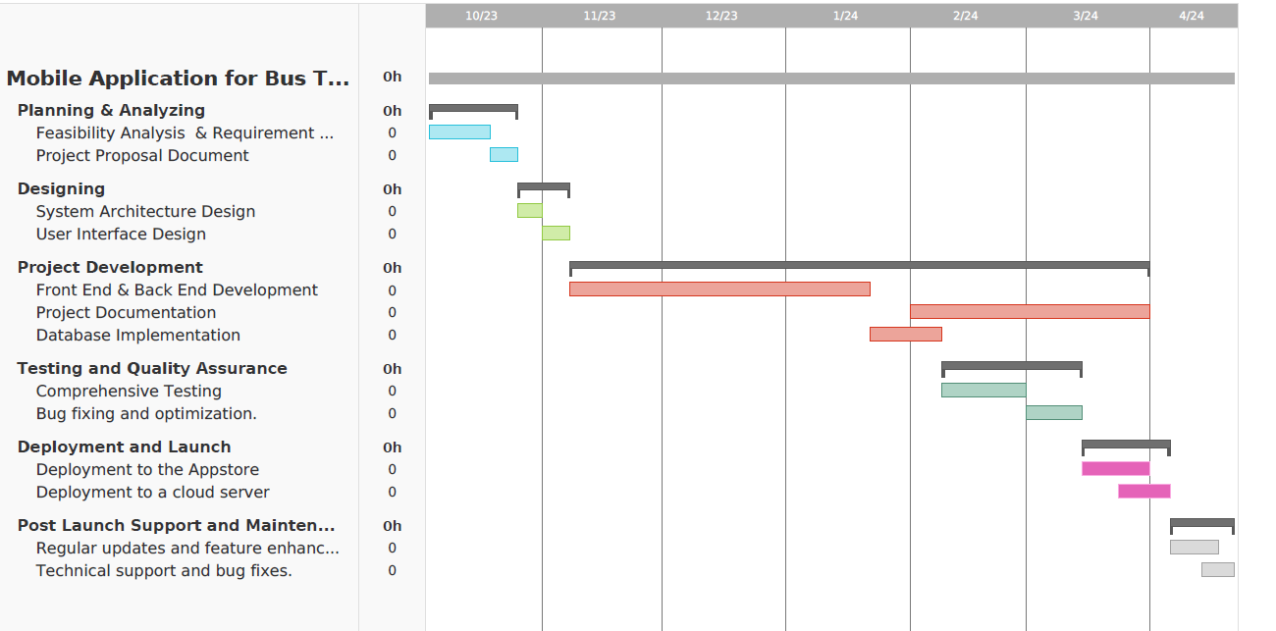We estimate that it will take around 6 months to finish developing the Bus Tracking and Booking Application. The following is the project's timeline:

Month